NOVA HIGH SCHOOL
BASEBALL
2022

DATE | DAY | TEAM | TIME | LOCATION
2/15 | Tues. | University School  (Pre Season) | 7:00 PM | Nova
2/16 | Wed. | South Plantation  (Pre Season) | 7:00 PM | Nova
2/23 | Wed. | Coral Springs | 6:30 PM | Coral Springs
2/25 | Fri. | South Plantation | 7:00 PM | Nova
3/1 | Tues. | Cooper City | 7:00 PM | Nova
3/3 | Thurs. | Ft Lauderdale | 4:00 PM | Nova
3/7 | Mon. | Everglades | 7:00 PM | Nova
3/8 | Tues. | Cardinal Gibbons | 4:00 PM | Cardinal Gibbons
3/14 | Mon. | Flanagan | 6:30 PM | Flanagan
3/15 | Tues. | Santaluces | 7:00 PM | Nova
3/21 -3/24 | Mon. -Thurs. | Spring Break Classic | TBD | TBD
3/29 | Tues. | Cypress Bay | 6:30 PM | Cypress Bay
3/30 | Wed. | Pines Charter | 5:45 PM | Pembroke Lakes
4/4 | Mon. | Hollywood Hills | 7:00 PM | Nova
4/7 | Thurs. | McArthur | 7:00 PM | Nova
4/8 | Fri.. | Monarch | 7:00 PM | Nova
4/12 | Tues. | Western | 7:00 PM | Nova
4/13 | Wed. | Coral Springs Charter | 6:30 PM | Cypress Park
4/19 | Tues. | South Broward | 7:00 PM | Nova
4/21 | Thurs. | Northeast | 7:00 PM | Nova
4/27 | Wed. | Pompano Beach | 7:00 PM | Nova
4/28 | Thurs. | St. Thomas | 6:30 PM | St. Thomas

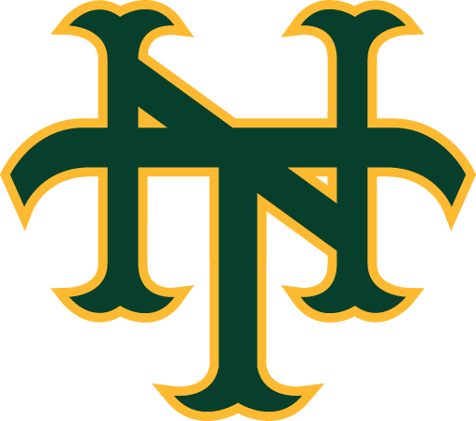

As of 2/08/22

