NOVA HIGH SCHOOL
FLAG FOOTBALL
2022

DATE | DAY | TEAM | TIME | LOCATION
2/26 | Sat. | Jamboree | TBD | McArthur
3/8 | Tues. | South Plantation | 6:00 PM | Nova
3/10 | Thurs. | Miramar | 4:30 PM | Miramar
3/16 | Wed. | Cypress Bay | 6:00 PM | Nova
3/17 | Thurs. | Coconut Creek | 4:30 PM | Coconut Creek
3/29 | Tues. | South Broward | 6:00 PM | Nova
3/31 | Thurs. | Hallandale | 4:30 PM | Hallandale
4/5 | Tues. | Dillard | 4:30 PM | Dillard
4/7 | Thurs. | Pines Charter | 6:00 PM | Nova
4/11 | Mon. | Flanagan | 6:00 PM | Nova
4/14 | Thurs. | Taravella | 6:00 PM | Nova
4/21 | Thurs. | Plantation | 6:00 PM | Nova
TBD | TBD | FHSAA Districts | TBD | Dillard

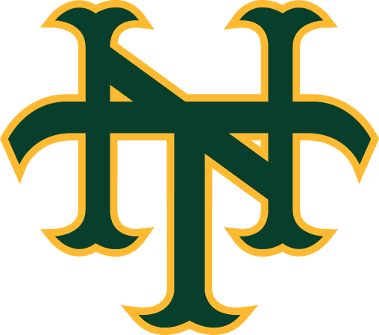

As of 2/08/22

