NOVA HIGH SCHOOL
SOFTBALL
2022

DATE | DAY | TEAM | TIME | LOCATION
2/22 | Tues. | Everglades | 6:30 PM | Nova
2/24 | Thurs. | St. Thomas | 6:30 PM | Nova
3/1 | Wed. | Somerset Academy | 6:30 PM | Nova
3/3 | Thurs. | Flanagan | 4:00 PM | Flanagan
3/4 | Fri. | Coral Springs | 6:30 PM | Nova
3/8 | Tues. | Ft. Lauderdale | 6:30 PM | Nova
3/9 | Wed. | Deerfield Beach | 6:30 PM | Nova
3/15 | Tues. | West Broward | 6:30 PM | Nova
3/17 | Thurs. | Cypress Bay | 6:30 PM | Nova
3/30 | Wed. | South Broward | 4:00 PM | South Broward
3/31 | Thurs. | Western | 6:30 PM | Nova
4/1 | Fri. | South Plantation | 4:00 PM | South Plantation
4/4 | Mon. | Douglas | 4:00 PM | Douglas
4/5 | Tues. | Hollywood Hills | 6:30 PM | Nova
4/8 | Fri. | Coral Glades | 6:30 PM | Nova
4/13 | Wed. | Cardinal Gibbons | 4:00 PM | Cardinal Gibbons
4/19 | Tues. | Pompano Beach | 6:30 PM | Nova
4/20 | Wed. | Monarch | 4:00 PM | Monarch

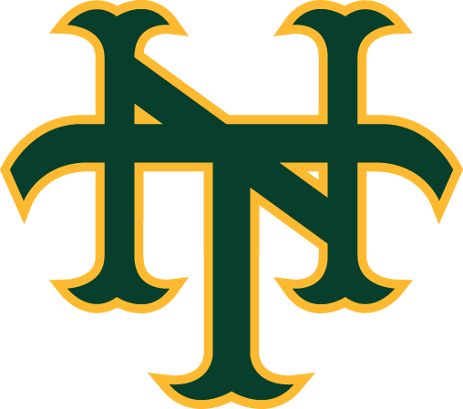

As of 2/08/22

