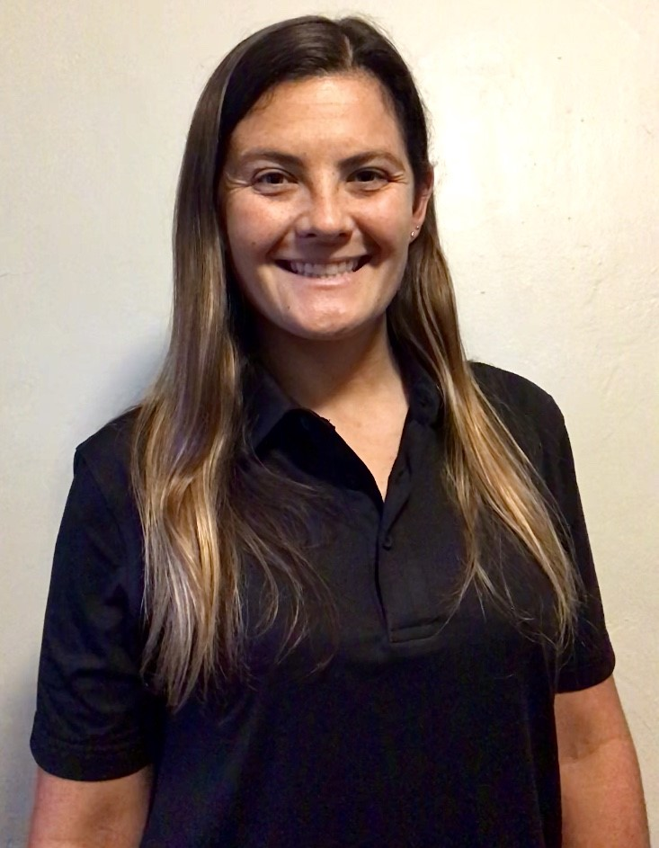

**Coach Bri Skinner**

**Head Softball Coach**

**Head Volleyball Coach**

[Brionna.Skinner@browardschools.com](mailto:Brionna.Skinner@browardschools.com)

**Nova High School Coaching:**

* 2019-2020 first year Head Softball Coach
* 2020-2021 first year Head Volleyball Coach

**College:**

* Graduated from East Carolina University 2012 in Greenville, NC
* Bachelor’s Degree in Business Management, Accounting
* Bachelor’s Degree in Hispanic Studies, Spanish

**Athletic Background:**

* I’ve been playing baseball for over 25 years and currently play on a Women’s Baseball Team and have experience with the USA Women’s National Baseball Team. I played Club Softball at ECU where we were top ten in the nation all 5 years and went to the World Series each year.
* I grew up playing soccer, volleyball and basketball in NC. I currently play in a Flag Football League and we have a travel team that plays throughout the year all over the nation.

**Personal:**

* I have lived in Florida for 3+ years now with two beautiful Siberian Huskies. I am the oldest of three, two younger sisters that live in NC and Cali. My favorite sport teams are the Duke Basketball and the New York Yankees. Outside of sports, I enjoy reading books and puzzling.