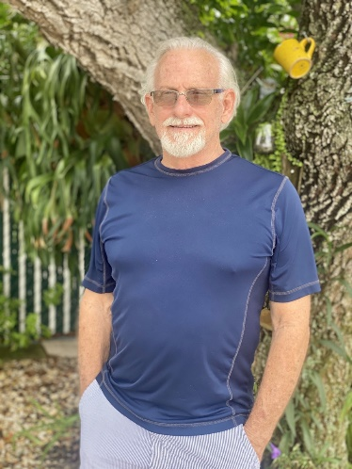

Coach John Bua

Head Tennis Coach
Boys & Girls
john.bua@browardschools.com

I have been a teacher for 49 years in Broward County and have coached high school sports teams since 1990. I began my coaching career at Western High School guiding the Lady Wildcats Soccer Team to a Regional Championship in 1992. I was then honored by being presented with the Miami Herald’s Soccer Coach of the Year. Our team subsequently won 8 district titles in 10 years.
In 2001, I transferred to the Western Golf Team and there I have been privileged to see our team have remarkable success. Over the years the golf team has represented Western High five times at the Golf State Finals. In 2014, the Sun Sentinel honored me with the Golf Coach of the Year. Although I transferred to Nova High School in 2011, I have continued to coach the Western Golf Team.
In 2011, I accepted the reigns of the Nova Tennis Team. We are a developing team with real promise. We enjoy our comradery and make the experience a pleasure for all. Over the years we have had a tremendous sampling of Nova’s finest students. Every player is an integral part of our team and is personally striving for their best. We will strive to win, but win or lose, we always will smile and have fun.

