NOVA HIGH SCHOOL
2021 - 2022
COMPETITIVE CHEER

DATE | DAY | TEAMS | TIME | LOCATION
11/16 | Tues. | Miramar  Cooper City  Flanagan  Western  West Broward | 6:00 PM | Miramar
11/29 | Mon. | Western  Cooper City  Miramar  South Plantation  Stranahan | 6:00 PM | Western
1/5 | Wed. | Miramar  Deerfield Beach  Flanagan  Plantation | 6:00 PM | Miramar
1/8 | Sat. | BCAA Championships | TBD | Coral Glades
1/14 | Fri. | FHSAA Regionals | TBD | Coral Glades

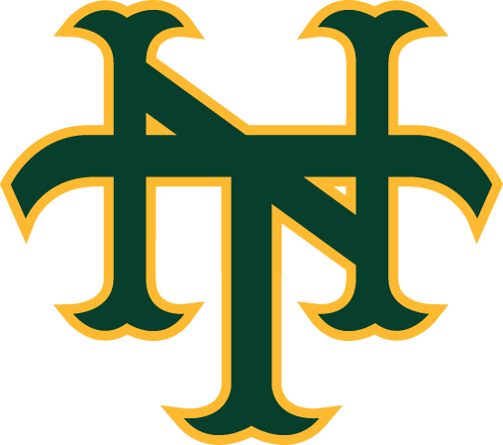

As of 10/21/21

