NOVA HIGH SCHOOL
2021-2022
BOYS BASKETBALL

DATE | DAY | TEAM | TIME | LOCATION
11/17 | Wed. | Bucks Pre-Season Classic | 6:00 PM | Deerfield Beach
11/20 | Sat. | Bucks Pre-Season Classic | 5:00 PM | Deerfield Beach
11/29 | Mon. | Stranahan | 8:00 PM | Nova
11/30 | Tues. | Boyd Anderson | 7:30 PM | Boyd Anderson
12/6 | Mon. | Cypress Bay | 7:30 PM | Cypress Bay
12/7 | Tues. | Northeast | 8:00 PM | Nova
12/9 | Thurs. | Deerfield Beach | 7:30 PM | Deerfield Beach
12/13 | Mon. | Hollywood Hills | 7:30 PM | Hollywood Hills
12/14 | Tues. | Cardinal Gibbons | 8:00 PM | Nova
12/16 | Thurs. | Hallandale | 8:00 PM | Nova
TBD | TBD | Holiday Classic Tournament | TBD | TBD
1/4 | Tues. | Ft Lauderdale | 7:30 PM | Ft Lauderdale
1/6 | Thurs. | Coral Springs | 8:00 PM | Nova
1/11 | Tues. | Miramar | 7:30 PM | Miramar
1/13 | Thurs. | South Broward | 7:30 PM | South Broward
1/14 | Fri. | Monarch | 7:30 PM | Nova
1/18 | Tues. | South Plantation | 7:30 PM | South Plantation
1/19 | Wed. | University School | 8:00 PM | Nova
1/24 | Mon. | Cooper City | 7:30 PM | Nova
1/31 | Mon. | Everglades | 7:30 PM | Everglades
2/1 | Tues. | West Broward | 7:30 PM | Nova

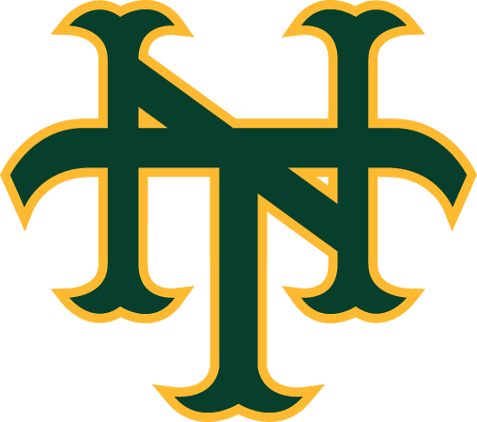

As of 11/5/21

