NOVA HIGH SCHOOL
2021-2022
GIRLS BASKETBALL

DATE | DAY | TEAM | TIME | LOCATION
11/9 | Tues. | Lady Bucks Pre-Season Classic | 7:30 PM | Deerfield Beach
11/11 | Thurs. | Lady Bucks Pre-Season Classic | 7:30 PM | Deerfield Beach
11/16 | Tues. | McArthur | 6:30 PM | Nova
11/18 | Thurs. | Miami Christian | 6:30 PM | Nova
11/29 | Mon. | Stranahan | 6:30 PM | Nova
11/30 | Tues. | Boyd Anderson | 6:00 PM | Boyd Anderson
12/2 | Thurs. | Santaluces | 7:00 PM | Santaluces
12/6 | Mon. | Cypress Bay | 6:00 PM | Cypress Bay
12/7 | Tues. | Northeast | 6:30 PM | Nova
12/14 | Tues. | Cardinal Gibbons | 6:30 PM | Nova
12/16 | Thurs. | Hallandale | 6:30 PM | Nova
12/27 – 12/29 | TBD | Palm Beach Shootout | TBD | TBD
1/4 | Tues. | Ft Lauderdale | 6:00 PM | Ft Lauderdale
1/6 | Thurs. | Coral Springs | 6:30 PM | Nova
1/8 | Sat. | SUTS New Year Classic | TBD | SLAM Academy
1/11 | Tues. | Miramar | 6:00 PM | Miramar
1/13 | Thurs. | South Broward | 6:00 PM | South Broward
1/15 | Sat. | MLK Classic | TBD | TBD
1/18 | Tues. | South Plantation | 6:00 PM | South Plantation
1/19 | Wed. | University School | 6:30 PM | Nova
1/20 | Thurs. | Somerset Silver Palms | 7:00 PM | Somerset Silver Palms
1/24 | Mon. | Cooper City | 6:30 PM | Nova

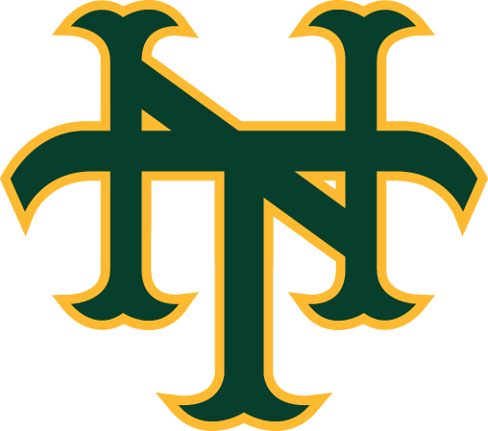

As of 10/21/21

