NOVA HIGH SCHOOL
2021-2022
WRESTLING

DATE | DAY | TEAM | TIME | LOCATION
12/3 | Fri. | Coral Springs IBT | 5:00 PM | Coral Springs
12/4 | Sat. | Coral Springs IBT | 9:00 AM | Coral Springs
12/8 | Wed. | JV Tournament | TBD | Cardinal Gibbons
12/14 | Tues. | JV Tournament | TBD | Cardinal Gibbons
12/15 | Wed. | West Broward  American Heritage | 5:00 PM | Nova
12/17 | Fri. | Archbishop McCarthy | TBD | Archbishop McCarthy
12/18 | Sat. | Archbishop McCarthy | TBD | Archbishop McCarthy
1/8 | Sat. | District Duals | TBD | TBD
1/13 | Thurs. | District Teams | TBD | TBD
1/14 | Fri. | Battle of the Bay | 1:00 PM | Cypress Bay
1/15 | Sat. | Battle of the Bay | 8:00 AM | Cypress Bay
1/18 | Tues. | JV Tournament | TBD | Gibbons
1/20 | Thurs. | Deerfield Beach  Miramar | 5:00 PM | Nova
1/25 | Tues. | JV Tournament | TBD | Cardinal Gibbons
1/28 | Fri. | BCAA County Championships | 9:00 AM | TBD
1/29 | Sat. | BCAA County Championships | 9:00 AM | TBD
2/2 | Wed. | McArthur/South Plantation | 6:00 PM | McArthur
2/9 | Wed. | Cooper City | 6:00 PM | Cooper City
2/11 | Fri. | Hollywood Hills | 6:00 PM | Hollywood Hills
2/12 | Sat. | JV County Championships | 8:00 AM | Nova

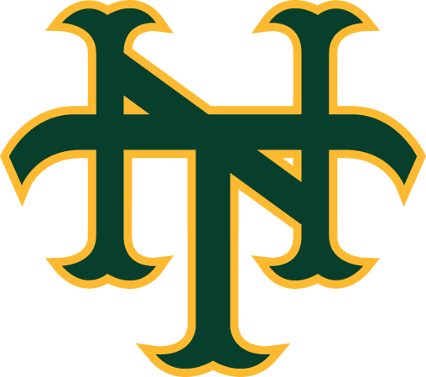

As of 11/15/21

