GLADES MIDDLE SCHOOL

ESOL Resources

There are many resources parents can access to assist in their children’s academic success. Below are some resources for valuable information and web sites for you and your students to enjoy. Return often for updates.
Department Brochures
Developing Reading Skills Brochure
Second Language Acquisition Brochure
Resources – Textbooks(link is external)
Registration(link is external)
What you need to register your child in Broward County Public Schools.
Graduation Requirements(link is external)
Find out all the information needed to graduate from Broward County Public Schools.
Student Code of Conduct(link is external)
The Code of Student Conduct outlines appropriate student behavior.
Virtual Counselor(link is external)
Check student's academic performance and school data on line. Please be advised that you will need your student's number which can be provided by contacting your school. Broward Virtual Education(link is external)
Broward County students have the opportunity to take courses for high school credit taught online by Broward County teachers. Parent Toolkit(link is external)
Track and support your child's academic growth. También en español aquí: Parent Toolkit en Español(link is external)
Aldea Educativa Magazine(link is external) (Spanish Resource)
Revista dedicada a la educación. Dirigida a la comunidad hispana y escrita en español.
The International Children's Library(link is external)
A digital library offering free e-books for kids in over 40 languages.
Safe Kids(link is external)
A comprehensive package of information and resources on safe Internet use.
Computer Guide to Online Safety and Viruses(link is external)
How to stay safe and malware-free while online. **Thanks to Ms. Kelly Graves and her students for this contribution**
GetNetWise(link is external)
Guides and child safe Internet links. www.wiredsafety.org(link is external)
The world's largest online safety and help group
Common Sense Media(link is external) -A very comprehensive site for both parents and teachers.
American Library Assoc. - Great Websites For Kids(link is external)
Keeping Kids & Teens Safe on the Internet (link is external)
Family Guide To Cyberspace(link is external)
Global School Net(link is external) and Starfall.com(link is external) Reading for your kids
Content Resource Links
Geography(link is external)
History(link is external)
Math(link is external)
Oceanography(link is external)
(link is external)Reading(link is external)
Technology(link is external)
Writing(link is external)
Funbrain(link is external)
Dictionaries & Encyclopedias
Webster.com(link is external)
Britannica.com(link is external)
Encyclopedia.com(link is external)
Worldbook.com(link is external)
Rhyme Zone Dictionary(link is external)
Sign Language Dictionary

- ESOL Adult Classes
- http://www.broward.k12.fl.us/css/Web_Portal/

GLADES MIDDLE SCHOOL ESOL CONTACT:
Daureene Reyes-Greenstein, M.S.,TESOL

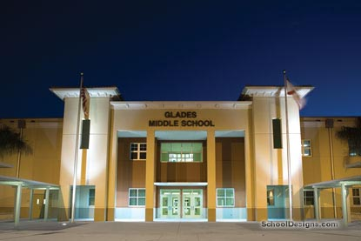

Copyright © Broward County Public Schools | Information & Technology | 7720 West Oakland Park Blvd. Sunrise, FL 33351 | (754) 321-0000
Nondiscrimination & Reasonable Accommodation Statement | Privacy Statement

