The Illustrate-a-Book award ceremony is this Saturday, May 6th at 11am at the Oakland Park Library 1298 N.E. 37th Street Oakland Park, FL 33334. All members of the community are invited to attend. We look forward to seeing you all.

Best regards,

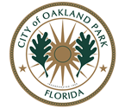 | Brittney Farley  Youth Services Librarian  Ethel M. Gordon Oakland Park Library  City of Oakland Park  1298 N.E. 37th Street  Oakland Park, FL 33334  954-630-4372  brittney.farley@oaklandparkfl.gov | www.oaklandparkfl.gov

