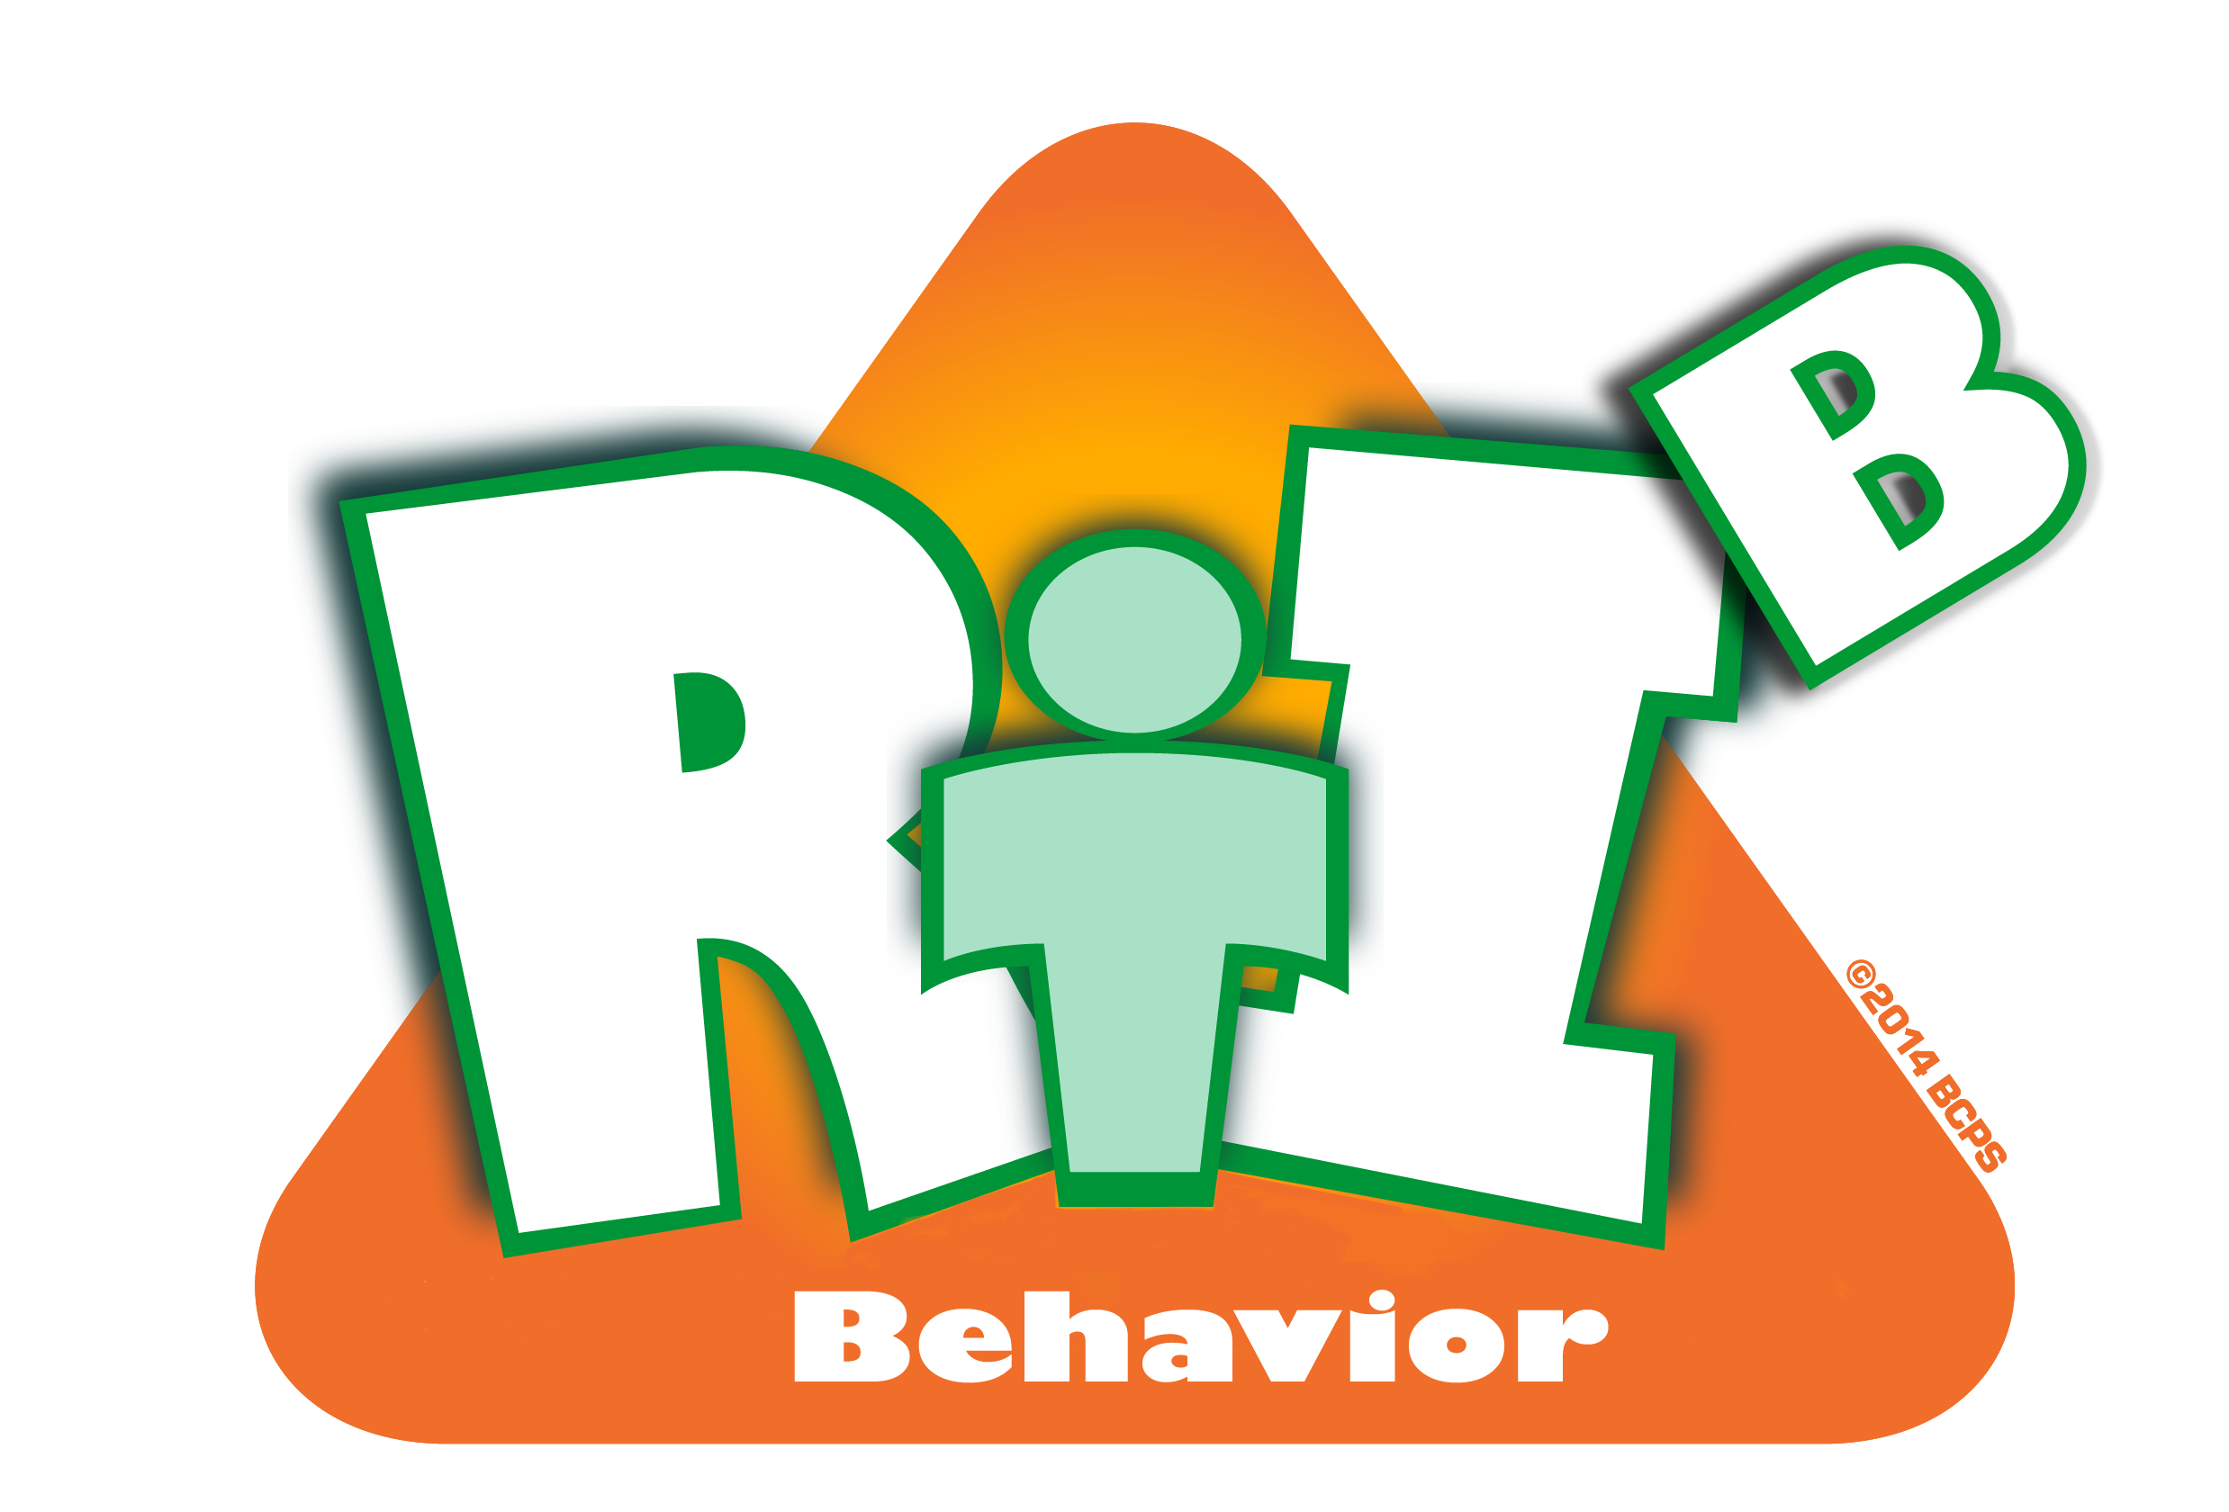
Broward County Public Schools

RtI:B Action Plan Guide
CE
7
Critical Element
Lesson Plans for Teaching Behavior
Lesson Plans for Teaching Behavior
Critical Element | Considerations | To-do List | Person Responsible | Follow up or  Completion Date
 | Use Your Data:  - Last year’s data (historical trends)  - Current data  - Staff and family feedback (surveys, focus groups)  to determine which behavior lesson plans are needed at your school | Analyze data in BASIS. Create surveys.
 | Lesson Plan Development: Design your own lesson plans or use what is already available (web search, Character Traits, Skillstreaming, Go Leaps). Customize lesson plans to meet the specific needs of your school and students. | Review Lesson Plan websites.
 | Inform and involve stakeholders. | Teach implementers how to deliver the Lesson Plans.
 |  | Inform students and families of lesson plans

 | Develop a schedule for delivering lesson plans | Develop a schedule of multiple lesson dates.
 |  | Plan specific time for teaching behavior lesson plans
 | Create a monitoring plan to ensure the implementation of Lesson Plans are delivered equally, consistently, and effectively. | How do we know we’re doing what we say we’re going to do?
 | Fidelity of implementation and Student Outcome Data is shared with team and faculty regularly | Schedule dates for staff presentation and for other stakeholders.
 |  | Create a method to collect feedback
 | Other:
 | Other:

