**Make a friend. Make a change. Make a difference.**

**SPORTS:**

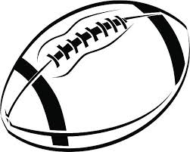

**Fall**

Football

Swimming

Bowling

Girls Volleyball

Cross Country

Golf

**Winter**

Basketball

Competitive Cheer

Soccer

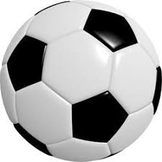Wrestling

**Spring**

Baseball

Softball

Tennis

Water Polo

Track & Field

Flag Football

Boys Volleyball

Lacrosse

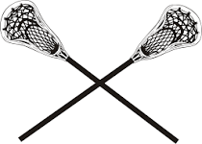

*Some clubs are co-curricular: You must be in the class to be in the club, and some clubs require an application. You may contact the club sponsor for additional information.

*This list is subject to change. Additional information, including the club sponsors, is listed on our website: *www.coralgladeshigh.com*

**CLUBS:**

Freshmen Class

Sophomore Class

Junior Class

Senior Class

Art

Asian American Assoc.

Astronomy

Band

Battle of the Books

Black Student Union

Caribbean Student Union

Chess

Chorus****

Debate/Forensics

DECA

Drama

Drone

Education Rocks

Engineering Design

eSports

FCCLA/Early Childhood

First Priority

Fishing

French

Future Educators of America

GSA Pride Alliance

Girl Up!

HOSA

Inter Club Committee

Interact

Key Club

Literary Magazine

Mentoring Tomorrow’s Leaders

Model U.N.

Modern Music Masters

Mu Alpha Theta/Math

National Art Society

National English Honor Society

National History Honor Society

National Honor Society

Science National Honor Society

Quill/Scroll Honor Society

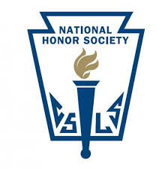NERD Coalition

Newspaper

Peer Counseling

Peer Palz

Poetry

Red Cross

SADD

Save What’s Left

Student Government

SHELL

Spanish

Sociedad Honoraria Hispánica

STEM Team

Student Law Association

Students Preventing Drowning

Students Working Against Tobacco

Technology

TV

UNICEF

Yearbook