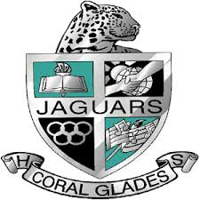
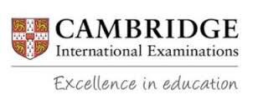
CORAL GLADES HIGH SCHOOL
CAMBRIDGE COURSE DESCRIPTIONS
You may be required to complete summer work. Check the Coral Glades website at the end of the school year.
Marine Science (Grades 10-12) Pre-requisite: Biology
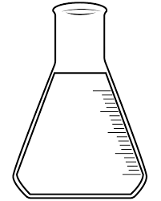
This class will provide students with a comprehensive and advanced overview of the unique characteristics of the marine environment exploring the physical and biological characteristics of seawater. Laboratory activities will include the use of the scientific method, measurements, laboratory apparatus usage and safety. Students will prepare for and must take the AICE Marine science exam. GROUP 1
English General Paper (Grades 9, 11, 12)
This course fulfills a student’s English I, III, or IV English requirement. It encourages students to develop a maturity of critical thought and argument, and a mastery of expression in the English language. Students use advanced writing strategies and techniques as they write about a broad range of topics including politics, economics, science technology, and the arts. Students will prepare for and must take the AICE English General Paper exam. GROUP 4
English Language (Grade 10)
Cambridge International AS English Language provides learners with the opportunity to study English language and its use in communication. Learners will be encouraged to respond critically to a wide variety of texts in a range of forms, styles and contexts, and to promote skills of communication, reading, research and analysis. Through their study, learners will develop an ability to read and analyze material, gaining further knowledge and understanding of English language features and issues. Learners will also develop the skills of writing clearly, accurately, creatively and effectively for different purposes and audiences. Students must take the English Language exam. GROUP 2
Spanish Language (Grade 10-12)
The AS Level Spanish syllabus enables learners to achieve greater fluency, accuracy and confidence in the language as it is spoken and written and improve their communication skills. They will learn how to improve their use of Spanish in a variety of situations, understanding how to read texts and other source materials, extract information, initiate conversations and respond to questions both orally and in writing. Students will prepare for and must take the AICE Spanish Language exam. GROUP 2
Thinking Skills AS level, A level (Grades 9-12) Enrolled in geometry or higher
Thinking Skills develops a set of transferable skills, including critical thinking, reasoning and problem solving, that students can apply across a wide range of subjects and complex real-world issues. The syllabus enables students to develop their ability to analyze unfamiliar problems, devise problem solving strategies, and evaluate the diverse ways a problem may be solved. During a Thinking Skills course, students learn to put their personal views aside in favor of examining and evaluating the evidence. Students learn how to make informed and reasoned decisions and construct evidence-based arguments. Students will prepare for and must take the AICE Thinking Skills exam. GROUP 4
History – (European grade 10- satisfies World History credit/American grade 11 satisfies U.S. History credit)
Cambridge International AS History is a flexible and wide-ranging syllabus covering modern history in the nineteenth and twentieth centuries. The emphasis is again on both historical knowledge and on the skills required for historical research. Learners develop an understanding of cause and effect, continuity and change, similarity and difference, and use historical evidence as part of their studies. Students will prepare for and must take the AICE History exam. GROUP 3
Global Perspectives AS level, A level (Grades 10 – 12)
Cambridge International AS Level Global Perspectives and Research prepares learners for positive engagement with our rapidly changing world. Learners develop research, thinking, reasoning and communication skills by following an approach to analyzing and evaluating arguments and perspectives. Collaborative skills are enhanced through participation in a team project. In addition, students will create a video and write a research paper based on a global issue. Students will also prepare for and must take the AICE Global Perspectives exam. COMPULSORY
Business (Grades 10-12)
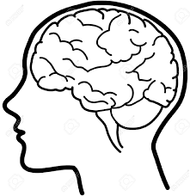
The Business syllabus enables learners to understand and appreciate the nature and scope of business, and the role it plays in society. The syllabus covers economic, environmental, ethical, governmental, legal, social and technological issues, and encourages a critical understanding of organizations, the markets they serve and the process of adding value. Learners examine the management of organizations and, in particular, the process of decision-making in a dynamic external environment. Students will prepare for and must take the AICE Business exam. GROUP 3
Psychology (Grades 10-12)
Cambridge International AS Level Psychology learners develop their appreciation of the subject by exploring the ways in which psychology is conducted. As part of their studies, learners also review important research; this provides an insight into the ways in which psychology has been applied, thereby leading to a better understanding of key approaches, research methods and issues and debates. The syllabus reflects four core areas of psychology, namely biological, cognitive, learning and social; it also relates psychology to abnormality, consumer behavior, health and organizations. Students will prepare for and must take the AICE Psychology exam. GROUP 1 OR 3
Environmental Management (Grades 10-12) Pre-requisite: Biology
This AS Level syllabus develops scientific knowledge and understanding of global environmental issues and theories, and of the policies and strategies for managing the environment. The course covers the sustainable use and management of resources, and strategies that aim to protect environments. Learners will interpret and analyse data and do investigative work. Case studies allow teachers to choose their own examples to investigate, which may be local, regional or global. Students will prepare for and must take the AICE Environmental Management exam. GROUP 1 or 3
Media Studies AS, A level (Grades 10-12)
Cambridge International AS Level Media Studies offers learners the chance to develop an understanding and appreciation of the place of media in our everyday lives. The syllabus enables learners to take a hands-on approach to the subject. Through the coursework components - the Foundation Portfolio for AS Level students create their own media products from planning through to execution. Learners also consider and analyze examples from existing media, examining production processes and technologies and the effects they achieve. In addition to creating a media product, students will prepare for and must take the AICE Media Studies exam. GROUP 3
Physical Education AS level (10-12)
The Physical Education syllabus is both practical and theoretical, covering anatomy and physiology, movement skills and contemporary studies in sport. Learners are encouraged to try out a range of physical activities, including team and individual sports, games, and outdoor activities, and then use the theoretical knowledge they have gained to analyse the different factors influencing performance. GROUP 1

Geography AS level (9-12)
The syllabus is wide-ranging and comprises a variety of options. Learners can study topics such as hydrology and fluvial geomorphology, atmosphere and weather, rocks and weathering, population change and settlement dynamics. The syllabus considers a range of environments, from tropical to arid, and learners can also study subjects such as environmental management, global interdependence and economic transition. Students will prepare for and must take the AICE Geography exam. GROUP 3

