Gators,
Broward College is offering Dual Enrollment for the SUMMER term for students in grades 9-11th that have an unweighted GPA of a 3.0 of higher. In order to qualify, you must also pass the ACCUPLACER Exam or have a qualified SAT/ACT, PERT score. https://www.broward.edu/academics/dual-enrollment/eligibility-requirements.html
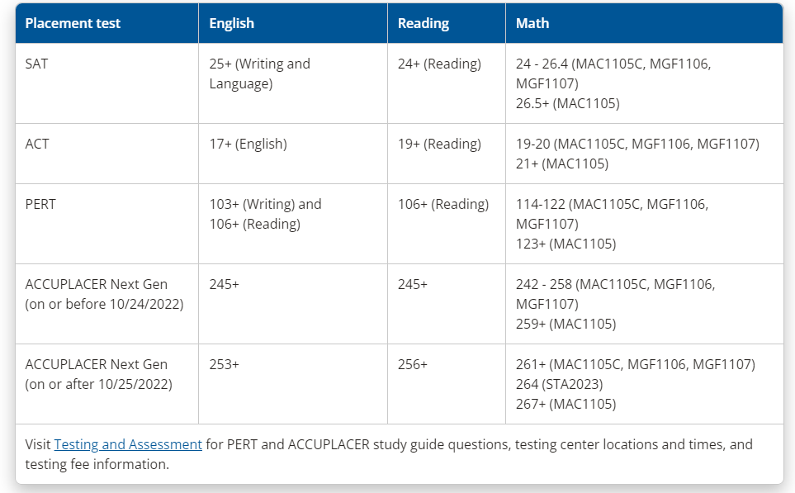
Any tests taken on or after October 25, 2022 will follow the new cut off scores as listed below. This information is on the BC Testing Website (www.broward.edu/testing)

If you do not have a qualified score and are interested, please complete your testing EARLY by following the below steps. Do Not Wait until the Last Minute, the deadline for all testing and paperwork is due on Thursday, February 9, 2023

Student Deadline: Thursday, February 9, 2023. All placement testing completed PRIOR to February 9th, form submitted, and signed parent form uploaded-NO electronic signatures.

Summer 2023 Registration Date: IF THE PAPERWORK DEADLINE/CRITERIA WAS MET BY FEBRUARY 9TH, THE STUDENT REGISTERS ON THE BC WEBSITE FOR THEIR COURSE(S) Wednesday, March 1, 2023. THERE ARE NO EXTENSIONS TO THE FEBRUARY 9TH DEADLINE.
-Students can only register for 1 summer course.

Updated Accuplacer Testing Information
- All remote testing for first time test takers will be a fee of $11.50.
- All in person testing for first time test takers will be no cost.
- All remote testing for retest attempts will be $43.50.
- All in person testing for retest attempts will be $33.50.
- ****Students can now make appointments at any campus by visiting www.broward.edu/testing.

Steps for Dual Enrollment
- Go to https://www.broward.edu/academics/dual-enrollment/
- Click appropriate icon
- If a student is new, the student must apply to BC online first.
- Complete the Remote Testing Request Form.
- Students will receive a voucher for testing to their personal email address. This may take up to 5 business days.
- Students should follow directions to schedule their exam.
- Students should share final scores with counselors.
- Complete the Dual Enrollment paperwork every semester: https://www.broward.edu/academics/dual-enrollment/students.html (Links to an external site.)
- If you are a continuing student, please click on the appropriate tile and follow the instructions.
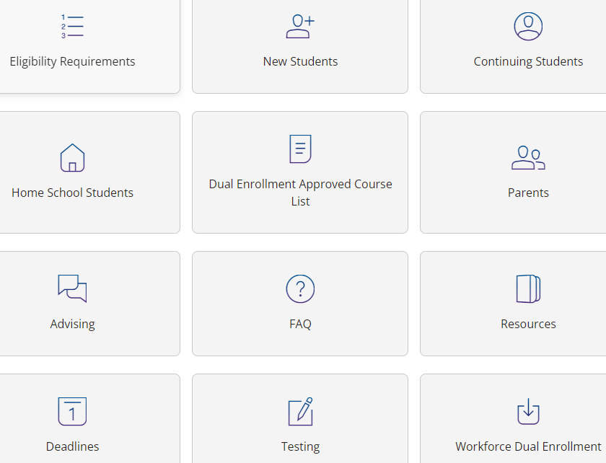

Important Information for the Summer:
Please be mindful that BC's "summer" term begins in May, do not register for a BC course that meets during high school hours while high school is in session!
There are 3 sessions to choose from for summer (only ONE course can be taken for summer session).
session 1: May 16-Aug 8
session 2: May 16-June 26
session 3: June 29-Aug 8
*New students, if you are having trouble with your Broward College application, please remember that you must first create a Broward College number (refer to student checklist). In addition, students and parents may visit www.broward.edu/dual for information on Dual Enrollment and Early Admissions and the list of all BC Approved Classes is also listed below.

District Guidelines for Dual Enrollment:
Grades 9-10: May take one* DE course per semester at BC for a maximum total of two courses during the school year and one summer course (if applicable). The DE class may be taken on the college campus, on the high school campus, or online.
Grade 11: May take two* total DE courses per semester at BC, UF, or any combination of those schools for a maximum total of four courses during the school year and one summer course. Both DE courses may be taken on the high school campus or if the student takes take one DE course on the college campus or online then the second DE course must be taken on the high school campus.
Grade 12: May take three* total DE courses per semester at BC, UF, or any combination of those schools for a maximum total of six courses during the school year. All DE courses may be taken on the high school campus; however, students may take a maximum of two DE courses on the college campus or online and the remaining DE course(s) must be taken on the high school campus.
*Courses with a required lab are considered one course, even though the lab is a separate course for registration purposes.
-Early Admissions students (SENIORS ONLY) must take a minimum of 12-15 credits each term during their senior year.
-Your total number of Dual Enrollment classes plus your Everglades High School classes must equal 7 Instructional classes. (Example: 2 DE courses plus 5 EHS equals 7 Instructional courses. Study Hall or Senior Privilege is NOT an Instructional class but will be added to your schedule.
-Broward College classes MUST NOT conflict with your EHS class schedule (NO morning classes or classes that begin/end when you are to be in class at Everglades)
-To remain eligible in the Dual Enrollment program, you must not earn a “D” or “F” in any Dual Enrollment course. In addition, your unweighted GPA must not ever fall below 3.0.
-Once you register for your courses, please submit a copy of your Broward College schedule to Mrs. Finn. If necessary, Mrs. Finn will adjust your EHS schedule to comply with DE rules and to ensure you are not taking duplicate courses. Gina.Alvarez@browardschools.com
-Follow the School Counseling Department @EHSGATORAIDE for updated Dual Enrollment Information.

